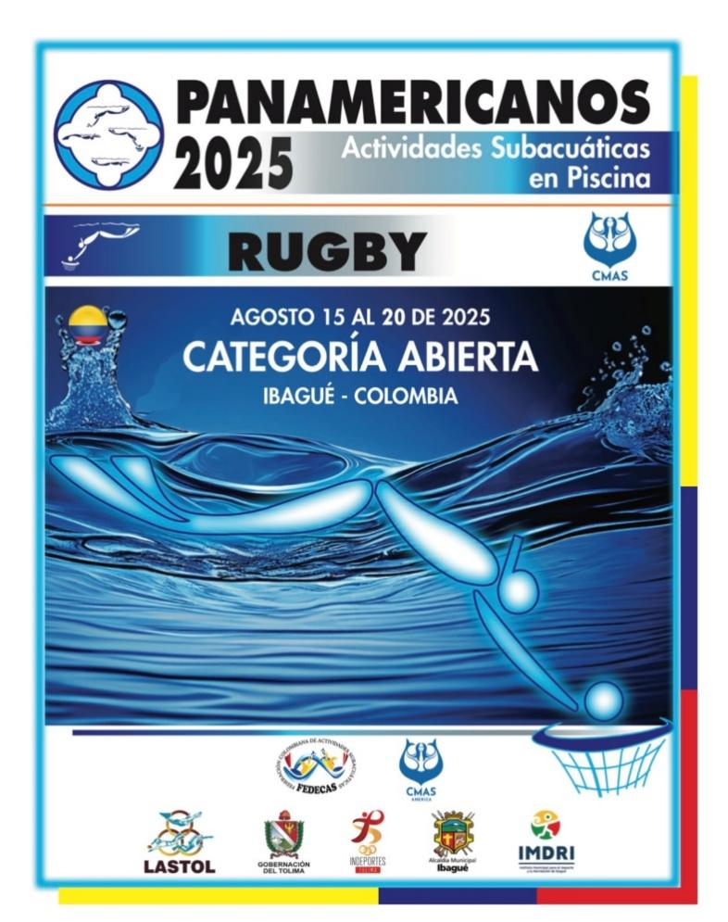

2025 CMAS Pan-American Championship Underwater Rugby

15th August - 20th August 2025

Ibagué, Colombia

**INFORMATION PACK**

## Invitation

### Championship Host Invitation

Dear Underwater Rugby Community,

The Colombian National Federation of Underwater Activities (FEDECAS) is thrilled to invite athletes, coaches, and supporters from across the Americas to participate in the **2025 CMAS Pan-American Underwater Rugby Championship**. This prestigious event will feature open category for both Men’s and Women’s divisions - Minimum age category of 15 years old, with no upper age limit.

Join us in Ibagué, Colombia, from **August 15 to August 20, 2025**, at the renowned Complejo Acuático - Parque Deportivo Ibagué. We eagerly anticipate your participation in this celebration of athleticism and camaraderie, as we come together to advance the sport of underwater rugby in the Americas.

Warm regards,

**William Peña**

President, Colombian National Federation of Underwater Activities

### Eligibility

The championship is open to national teams from countries across the Americas. Participants must be affiliated with their respective national underwater rugby federations and comply with CMAS regulations.

### Contact Details

|  |  |  |
| --- | --- | --- |
| **Communication medium** | **Address** | **Description** |
| For inquiries | **Email**: [uwrpan2025col@gmail.com](mailto:uwrpan2025col@gmail.com)  **Phone**: +57 3133145683  **Website**: [https://www.fedecas.org/panamericanos-rugby](https://www.fedecas.org/panamericanos-rugby%20) | For inquiries and further information |
| CMAS Portal  website | <https://portal.cmas.org/> | CMAS Sports Licences and Division Registration. |
| CMAS TV | <https://tv.cmas.org/> | Livestream of the competition |

## General Information

### Host City Location: Ibagué, Colombia

**About Ibagué**Ibagué, known as the "Musical Capital of Colombia," is a vibrant and culturally rich city located in the central region of Colombia. Nestled in the Andean mountains at an elevation of approximately 1,285 meters (4,216 feet) above sea level, Ibagué enjoys a pleasant climate with average temperatures ranging from 18°C (64°F) to 28°C (82°F) throughout the year.

The city is famous for its musical heritage, hosting annual events like the Festival Folclórico Colombiano, which celebrates Colombian traditional music and dance. In addition to its musical traditions, Ibagué offers a variety of cultural, historical, and natural attractions. Visitors can explore its parks, museums, and nearby natural wonders, such as the Nevado del Tolima volcano and the Combeima Canyon.

### Transportation to Ibagué

1. **By Air**
   * **Perales Airport (IBE)**: Ibagué is served by Perales Airport, which connects the city to Bogotá and other major Colombian cities. Direct flights from Bogotá's El Dorado International Airport (BOG) to Ibagué take approximately 20 minutes.
   * **International Travelers**: Most international travelers arrive in Colombia through Bogotá, Medellín, or Cali. From there, connecting flights to Ibagué are available.
2. **By Road**
   * **From Bogotá**: Ibagué is approximately 200 km (124 miles) west of Bogotá. The drive takes about 4-5 hours by car or intercity bus, depending on traffic and weather conditions. The route passes through scenic mountain landscapes, making it an enjoyable journey.
   * **From Medellín**: The distance from Medellín to Ibagué is about 260 km (162 miles), and the drive takes roughly 6-7 hours.
3. **By Bus**
   * Ibagué has a well-connected bus terminal offering services from major Colombian cities. Bus companies provide frequent and affordable routes to the city.

**Local Transportation in Ibagué**

* **Taxis**: Widely available and affordable for getting around the city.
* **Buses**: The local bus system connects different neighborhoods, including the sports complex where the championship will be held.
* **Ride-Sharing Services**: Popular apps like Uber and Didi operate in Ibagué for convenient travel.

Here are some airlines that operate flights to Ibagué:

* [Avianca](https://www.avianca.com/en_us/flights-to-ibague?utm_source=chatgpt.com): Offers direct flights from Bogotá to Ibagué.
* [LATAM](https://www.latamairlines.com/co/es) **Airlines**: Provides direct flights from Bogotá to Ibagué.
* [ClicAir](https://clicair.co/): Operates direct flights to Ibagué.

**Booking Flights**

You can book flights directly through the airlines' websites or use travel booking platforms to compare prices and schedules:

* [Expedia](https://www.expedia.com/Cheap-Flights-To-Ibague.d602442.Travel-Guide-Flights?utm_source=chatgpt.com): Offers flight options to Ibagué.
* [Kayak](https://www.kayak.com/flight-routes/United-States-US0/Ibague-IBE?utm_source=chatgpt.com): Provides flight comparisons to Ibagué.
* [Skyscanner](https://www.skyscanner.com/flights-to/ibe/cheap-flights-to-ibague-airport.html?utm_source=chatgpt.com): Lists flights to Ibagué.

**Bus Services Bogota to Ibagué**

Ibagué is well-connected by road, with several bus companies offering services from major Colombian cities. Here are some options:

* **Velotax**: Provides bus services to and from Ibagué.  
   [Colombia by Bus](https://colombiabybus.com/velotax/?utm_source=chatgpt.com)
* **Expreso Bolivariano**: Offers routes connecting Ibagué with various cities.  
   [CheckMyBus](https://www.checkmybus.com/bogota-dc/ibague-to?utm_source=chatgpt.com)
* **Expreso Palmira**: Operates buses to Ibagué.  
   [Busbud](https://www.busbud.com/en/terminal-ibague/s/18658?utm_source=chatgpt.com)

### Venue Details: Complejo Acuático - Parque Deportivo Ibagué

**Overview**

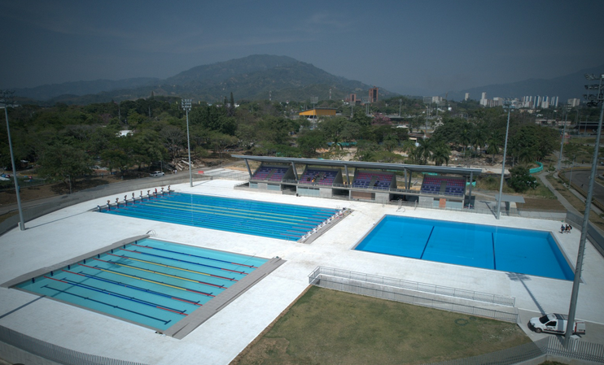

The Complejo Acuático at Parque Deportivo Ibagué is a state-of-the-art aquatic center designed to host national and international competitions. Inaugurated in September 2024, this facility has quickly become a central hub for aquatic sports in Colombia.

**Pool Specifications**

The complex features multiple pools tailored for various aquatic disciplines:

* **Competition Pool**: This pool measures 25 meters long and 10 meters in width, adhering to international standards for competitive swimming and underwater rugby. The depth is 5 meters, providing optimal conditions for underwater rugby matches. CMAS Authorization.
* **Training Pool**: A secondary pool designed for warm-ups and practice sessions. It measures 25 meters in length and 20 meters in width, with a uniform depth of 2 meters.

**Facilities and Amenities**

The aquatic center is equipped with modern amenities to ensure a comfortable experience for athletes and spectators:

* **Seating Capacity**: The venue can accommodate up to 1,500 spectators, offering clear views of the competition area.
* **Locker Rooms**: Separate facilities for male and female athletes, each equipped with showers, restrooms, and secure lockers.
* **Medical Facilities**: On-site medical room staffed with professionals to address any health concerns during events. an ambulance must be permanently on the site.
* **Accessibility**: The complex is designed to be accessible, with ramps and designated seating areas for individuals with disabilities.

For a closer look at the Complejo Acuático, you can watch the following video showcasing the facility: [Complejo Acuático - Parque Deportivo Ibagué *](https://www.youtube.com/watch?v=YvaxjpanuTI&embeds_referring_euri=https%3A%2F%2Fchatgpt.com%2F&source_ve_path=Mjg2NjQsMjg2NjY&themeRefresh=1)

[Video 2 Inauguration](https://www.youtube.com/watch?v=-_hZDcvFdDU)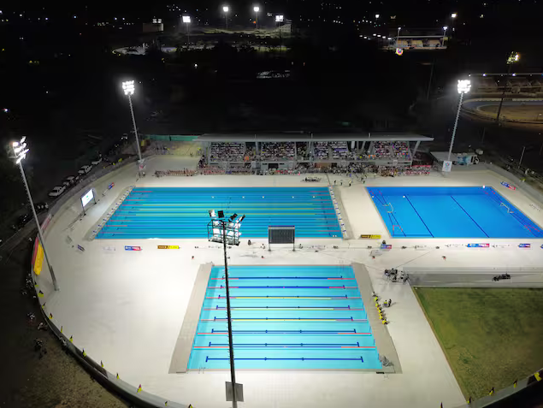

### Visa Requirements

**General Information**

Travellers visiting Colombia for tourism purposes, including participants and attendees of the 2025 CMAS Pan American Championship Underwater Rugby, must comply with the country's visa regulations. Colombia exempts citizens of certain countries from obtaining a tourist visa for short stays (typically up to 90 days).

**Visa-Exempt Countries**

Citizens from the following countries do **not** require a tourist visa to enter Colombia for stays of up to 90 days:

* **Americas**: Argentina, Bahamas, Barbados, Belize, Bolivia, Brazil, Canada, Chile, Costa Rica, Dominica, Dominican Republic, Ecuador, El Salvador, Guatemala, Guyana, Honduras, Jamaica, Mexico, Panama, Paraguay, Peru, Saint Kitts and Nevis, Saint Lucia, Saint Vincent and the Grenadines, Suriname, Trinidad and Tobago, United States, Uruguay, Venezuela.

Note: This list is not exhaustive. For a comprehensive and up-to-date list, please refer to the official Colombian Ministry of Foreign Affairs website.

**Useful Links**

* **Colombian Ministry of Foreign Affairs – Visa Information**:<https://www.cancilleria.gov.co/en/tourist-visa>
* **Visa Application Form**:<https://tramitesmre.cancilleria.gov.co/tramites/enlinea/solicitarVisa.xhtml>
* **List of Countries and Visa Requirements**:<https://colombia.travel/en/practical-information/visas-and-embassies>

**Recommendations**

* **Advance Planning**: Initiate the visa application process well ahead of your intended travel dates to accommodate processing times.
* **Stay Informed**: Visa policies can change; always refer to official sources for the most current information.
* **Health Requirements**: Ensure compliance with any vaccination requirements, such as yellow fever vaccination, especially if arriving from certain countries or planning to visit specific regions within Colombia.

### Additional Information

* **Language**: Spanish is the official language in Colombia.
* **Currency**: Colombian Peso (COP). Dollar to COP varies between 1 USD corresponding between 3700 and 4400 COP
* **Climate**: In August, Ibagué experiences mild temperatures, averaging between 18°C (64°F) and 28°C (82°F) with 70% humidity.
* **Time Zone**: Colombia Time (COT), UTC -5.
* Colombia follows the left-hand drive cars and people drive on the right-hand side of the road
* The metrical measure system is used in Colombia
* The standard electrical voltage in Colombia is 110 volts-60Hz. Plugs and outlets are Type A and B. Two flat parallel pins

When planning your trip to Ibagué for the 2025 CMAS Pan-American Championship Underwater Rugby, it's essential to budget for accommodation, food, and transportation. Here is an overview to assist you:

#### Accommodation

Ibagué offers a range of lodging options to suit various budgets:

* **Budget Hotels**: Prices start around $25 per night.  
   [Kayak](https://www.kayak.com/Ibague-Hotels.52784.hotel.ksp?utm_source=chatgpt.com)
* **Mid-Range Hotels**: Approximately $36 per night for 3-star hotels.  
   [Booking.com](https://www.booking.com/city/co/ibague.html?utm_source=chatgpt.com)
* **Luxury Hotels**: 4-star hotels average $60 per night, with 5-star options around $90 per night.  
   [Booking.com](https://www.booking.com/city/co/ibague.html?utm_source=chatgpt.com)

#### Food

Dining in Ibagué is affordable, with options ranging from street food to sit-down restaurants:

* **Fast Food Combo Meal**: Such as at McDonald's, costs about 30,000 COP (approximately $6).
* **Inexpensive Restaurant**: A meal costs about 21,938 COP (approximately $5.50).
* **Mid-Range Restaurant**: A three-course meal for two averages 90,000 COP (around $22.50).

Source: [Numbeo](https://www.numbeo.com/cost-of-living/in/Ibague-Colombia?utm_source=chatgpt.com)

#### Transportation

Getting around Ibagué is cost-effective:

* **Public Transportation**: Local buses are available, with fares typically low, though exact prices may vary.
* **Taxis and Ride-Sharing**: Services like Uber operate in Ibagué, offering convenient transportation. [Uber](https://www.uber.com/global/en/r/cities/ibague-tolima-co/?utm_source=chatgpt.com)

#### Web Links

* Official Event Website: [**https://www.fedecas.org/panamericanos-rugby**](https://www.fedecas.org/panamericanos-rugby)
* CMAS Website underwater Rugby: [**https://www.cmas.org/rugby/latest.html**](https://www.cmas.org/rugby/latest.html)
* CMAS Portal - To acquire Athlete LIcense:[**https://portal.cmas.org/**](https://portal.cmas.org/)
* CMAS TV:[**https://tv.cmas.org/page/65cde876f3f5bc66902d8a5d**](https://tv.cmas.org/page/65cde876f3f5bc66902d8a5d)
* Tourism Information: [Ibagué Tourism](https://strspecialist.com/colombia/ultimate-travel-tips-for-ibague/)

## Tournament Details

### Programme



### Rules

The event is organized under the following rules and guidelines:

* [CMAS UNDERWATER RUGBY INTERNATIONAL RULES V2024 01](https://www.cmas.org/document/cmas-underwater-rugby-international-rules-v2024-01/download.html)
* [Cmas Anti-doping](http://www.cmas.org/hockey/anti-doping)
* [CMAS Anti-doping Rules 2021](https://www.cmas.org/images/cmas_articles/84/CMAS_ADR_2021_-_Final_signed_1.pdf)
* [Conditions to obtain a CMAS License](https://www.cmas.org/images/cmas_articles/84/3_2023_06_12_CONDITIONS-TO-OBTAIN-AN-CMAS-LICENCE.pdf)

### Championship Divisions

The following grades are offered for this tournament and each National Federation can enter a maximum of one team per division.

The divisions are:

* Men’s
* Women’s

The minimum ages are: Minimum age category of 15 years old, with no upper age limit.

All athletes must possess a valid CMAS license available from [CMAS Portal](https://portal.cmas.org/). A waiver document form for all players must be submitted by all teams. For the athletes under 18, waiver document forms must be signed by their legal guardians.

### Playing mode:

A detailed playing mode and schedule of games will be sent to all participating federations after final entry has been closed. The composition is for round robin. The draw will be done after the publication of the schedule. The place and time of the draw will be announced one week in advance.

### Nationality of athletes participating in CMAS Championships:

All the athletes of a national team must have the nationality of the country or submit proof that they are resident in that country for 1 year at least. In the team, there can be a maximum of 30% foreign athletes.

### Additional Rules and Regulation for this Championships

### a. Any use of lubricants such as soap, shower gel, creams or Vaseline will be prohibited in the pool area because they severely deteriorate the quality of the water, which in turn degrades visibility in the pool both for players and video cameras. They may be used in the shower area but must be washed off before entering the pool.

### b. The amount of people watching games in the water will be limited to 2 per team. We will provide live streaming by the pool.

### c. When a penalty throw is called, diving is forbidden to all players not directly involved in the penalty throw’s execution for the duration of the penalty throw. If this rule is broken during the Championships, from thereon all players not directly involved in any penalty throw’s execution will be required to leave the water. This is meant to improve conditions for video recording.

**d**. **Dress Code**: The use of jerseys is not mandatory but allowed if it follows the team color, but it is mandatory that all players of a team must play with or without a jersey, one option must be chosen and inform to the organization email [uwrpan2025col@gmail.com](mailto:uwrpan2025col@gmail.com) .  If your team wants to use a jersey, all players of a team must wear matching gear - swimsuits or trunks and jerseys (female) / trunks and jerseys (male) - and caps of the same graphical design and the same number. The cut of the players’ gear within a team may differ if it is within the rules below:

i) Men must play in swimming trunks (speedos or shorts up to the knee) and jerseys ii) Women must play in either swimsuits or bikini bottoms and jerseys. It is also allowed to play in swimsuits and jerseys. If they wear jerseys, the jerseys also must be uniform for all players and if used, must be worn by all players of a team.

iii) All players must have their player’s number visibly displayed, at least on the back of their suit or jersey, the player’s name may be added. The number must be between 15cm and 30cm high. The strokes must be between 1,5cm and 3cm wide. iv) The number must stand out clearly from the background.

v) The jerseys must be tight fitted and elastic.

vi) The jerseys must be made of fabric, like the fabric of swimsuits or swimming trunks.

vii) For men, the jerseys must be long enough to be put inside the trunks.

viii) Shoulders shall not be covered by the jersey.

**e.** Should a team not be correctly dressed at game-time, they will receive a warning by the referee. If they cannot comply with the dress code within 5 minutes, the team is disqualified for the game and the game will set 3:0 in favor of the opponent.

i. Backup gear (jerseys and caps in both colors) will be available at the pool if needed for teams to borrow in case of unavailability or loss of their original equipment.

**f.** If a player’s jersey gets damaged during a game, the player is allowed to finish the game without a jersey. For the next game, the player must replace the damaged jersey.

**g.** If replacement jersey is not available:

i. Colors (team white / team dark) will be changed, so the team with the damaged jersey can use the jerseys that are still intact.

ii. If both teams have the same-colored jerseys damaged, dark, or white, so colors cannot be changed, both must play with the jersey set borrowed by the organization.

**h.** National Teams’ Swimsuits and Jersey Approval

i. All swimsuits, trunks and jerseys must be pre-approved before the Championships by the UWR Commission by sending an artwork showing the design no later than: June 30th,2025.

ii. To get the approval reply, please send the artwork to the following e-mail addresses: [uwrpan2025col@gmail.com](mailto:uwrpan2025col@gmail.com)

iii. Comprehensive equipment check will be performed after each team’s training session, during the days before the championship matches start. All equipment to be used during the championship must be presented at this equipment check.

iv. Before each match the referees will perform visual and if needed spot-checks of the teams.

v. Swimsuits, trunks, and jerseys not pre-approved could be rejected at the championship.

vi. The Head of the Local Organizing Committee, Technical Delegate and Chief Referee will jointly take the decision if the equipment is according to the rules or not. vii. National Teams Jerseys that have already been approved at other CMAS UWR Championships do not need to be presented again.

**i.** Suppliers If your team doesn’t have a supplier for the required underwater gear, we recommend the following company:

**Guasabro**

Main Contact: Jorge Franco

+57 3194100730

[guasabro@gmail.com](mailto:guasabro@gmail.com)

https://guasabro.com/ <https://www.instagram.com/guasabro/>

**j.** **Ball selection**

i. All balls for the ball selection need to be presented at the Team leader meeting.

ii. Maximum one ball per team will be allowed to be submitted for the Ball selection.

iii. The submitted balls will be checked by the referees before the Ball selection.

iv. The selected balls will be kept in custody by the referees, till the ball selection takes place.

v. The balls which will be submitted should fulfill the requirements of the CMAS Rules. vi. After the championship balls are selected, they will only be used for Championships games and otherwise will remain in custody by the referees.

**k**. **Game opening**: At the beginning of each game, the teams will make a pennant exchange, so please bring pennants from your federation.

**l.** **Photographs and Videos:** By participating at the CMAS Pan-American Championship Underwater Rugby, Ibague-Colombia 2025 all federations confirm that all participating athletes and delegation members agree that the organizing federation has the right to use pictures and video footage of the event as well as any of the pictures collected in advance or during the Championships for any promotional or documentary purposes.

### Additional Training Space Availability

Limited training space will be available prior to the competition. Teams interested in booking training sessions must contact the organizing committee in advance at [uwrpan2025col@gmail.com](mailto:uwrpan2025col@gmail.com) before July 30th 2025.

### Registration Process and Meetings

Registration, documents check and delivery of accreditation will be undertaken at the swimming pool venue for all teams. The registration and meeting will take place at the pool venue on August 16, 2025.

### Ceremonies

#### Opening Ceremony

The inauguration ceremony will take place on August 16, 2025, at the Complejo Acuático Ibague at 6:30 PM.

#### Awards and Closing Ceremony

The awards ceremony will be held immediately following the final matches on August 19th 2025. Medals and trophies will be presented to the top teams in each division.

## Officials

### Championships Officials

**Local organizing committee Chair:** Mr. William Peña (COL)

**Technical Delegate:** Mr Diego Rodriguez (USA)

**CMAS UWR Director:** Mr. Levent Çavaş (TUR)

**Local Organizing Coordinator:** Mr. Julio Luna (COL)

**Championships Chief Referee:** Mr. Horus Sepulveda (COL)

**Assistant Referee:** Mr. Juan C. Zapata (COL)

### Referees

International referees will be refereeing the Championships. Championships’ Chief Referee will be Mr. Horus Sepulveda from Colombian Federation will do the selection of referees.

## Team Entry Fees

### Registration

All information related to the registration can be found from CMAS Portal and championship’s web site.

### CMAS Athlete Licenses and Profiles

All teams must register for the CMAS championship via the online CMAS administration system. <https://portal.cmas.org/>. Your Underwater Federation has the login codes and passwords. The first step is for athletes to create their individual profile and request acceptance from the Federation.

All athletes are required to have their valid CMAS licenses in order to be able to enter into the competition area. Sports Licenses requests must be applied for via the online CMAS administration system also.

### Championship Entry Fee

The early entry fee is set at USD $3.000 per team-division. The due date for entry fees is 1st June 2025.

The late entry fee is set at USD $3.200 per team-division. No late entry will be accepted after the 15th July 2025.

The team entry fee covers the following costs:

* Opening-Closing ceremonies
* Pool for 1 training day and competition days
* Online transmission, broadband high speed internet connections brought to the pool sides for the online transmission (high speed broadband WIFI)
* LED panels at the pools
* Volunteers’ assistance throughout the Pan-American Championship
* Underwater cameras and underwater sound system
* first aid, medical service presence and ambulance
* anti-doping tests’ costs
* Hydration refill station

Request bank information to: [uwrpan2025col@gmail.com](mailto:uwrpan2025col@gmail.com)

### Summary of Fees

|  |  |  |
| --- | --- | --- |
| **Tournament Organizer Forms and Details** | **Fee** | **Deadline** |
| **USD** |  |
| Team Entry Fee (per team division) | 3,000 | 1st June 2025 |
| Late entry fee (per team division) | 3,200 | From 1st June 2025 to 15th July 2025 |
| Extra Party Ticket | 30 | Purchase at Venue |

## Deadlines & Conditions of Entry

All forms and payment confirmations must be completed on our website. They will get to the

Organizers in Colombia, LOC.

Further info: [uwrpan2025col@gmail.com](mailto:uwrpan2025col@gmail.com)

|  |  |  |
| --- | --- | --- |
| Tournament Organizer Forms and Details | Deadline |  |
| Team Registration Form- The preliminary  declaration of participating teams and them  estimated numbers submitted to the Organizing  Committee in Colombia and Tournament Director | No later than 1st June 2025 | Via tournament website  [**https://www.fedecas.org/panamericanos-rugby**](https://www.fedecas.org/panamericanos-rugby)  Annex 1 |
| Fees payment | Due 15th July 2025 |  |
| Purchase of CMAS athlete sports licences and Late entry sign up | 1st July 2025 | Via tournament website  <https://portal.cmas.org/> |
| Final Participants’ List, - indicating players, referees, coaches, managers, officials, accompanying family members etc., must be sent to the Organizing Committee | 15th July 2025 | Via tournament website  <https://portal.cmas.org/>  Annex 2 |